**Markov model with current information**

**1. Methold**

In the full model, The values of various variables are discretized, and time does not. We are concerned with the number of pending kick (H) and the change of voltage (V) of each neuron.

Previous work focused on the value of H, but the current information $I=\frac{S*H}{τ}$ is more critical and universal. In my model, I focus on the current information and discretize the time.

$$I_{i}^{EE}=\frac{S_{i}^{EE}*H_{i}^{EE }}{τ^{E}}$$

$$\begin{aligned}I_{i}^{EI}=\frac{S_{i}^{EI}*{{\left(V\right.}_{i}-V^{I})*H}_{i}^{EI }}{τ^{I}}\#\left(1\right)\end{aligned}$$

$$I_{i}=I_{i}^{EEx}+I_{i}^{EE}-I_{i}^{EI}$$

The generation of H is randomly distributed (uniform distribution), and the consume of H is exponential (Poisson distribution). So the variance of H is related to the mean (In the consumption stage, mean and var are equal. This is almost a Poisson distribution) .

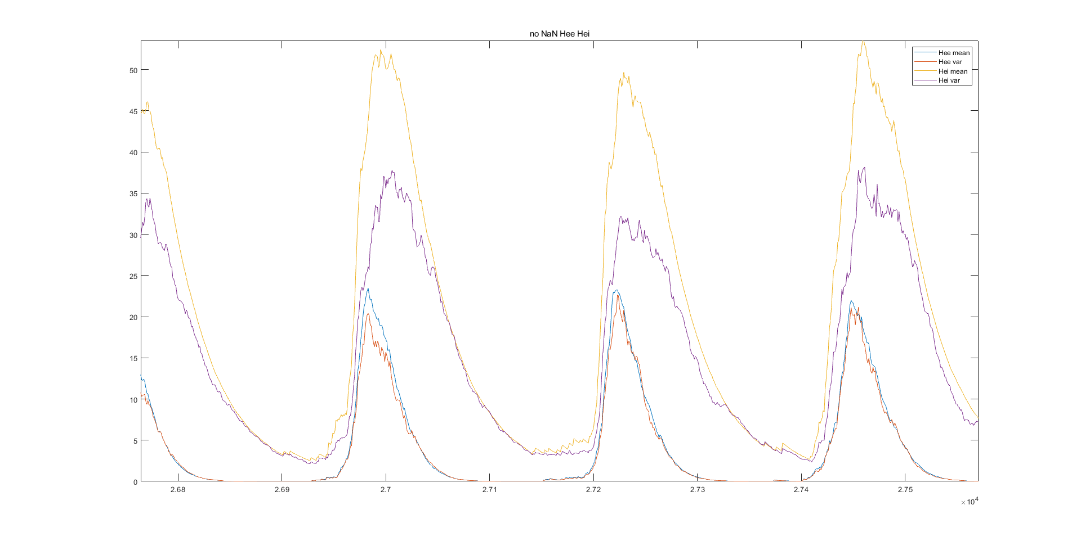 Figure 1. The mean value and variance of H basically coincide at the consumption stage, indicating Poisson distribution

Considering the calculation method of current $I_{i}^{EE}=\frac{S_{i}^{EE}*H_{i}^{EE }}{τ^{E}}$, it can be considered that the current is a stretched Poisson distribution. In other words, **the distribution of current Iee is a Gaussian distribution with correlation between mean and variance.** However, $I_{i}^{EI}=\frac{S_{i}^{EI}*{{\left(V\right.}_{i}-V^{I})*H}_{i}^{EI }}{τ^{I}}$ involves the product of normal distribution, so the distribution of Iei is more complex.

The voltage of neuron is "driven" by current, and it has its own rule, that is, it will return to zero when reaching M and enter the refractory period: $V_{i}^{t+1}=V_{i}^{t}+I_{i}, V_{i}^{t+1}=0 if V_{i}^{t}+I_{i}>=M$. This also explains why when no neuron reaches the threshold, the voltage distribution is very close to the Gaussian distribution. When neurons start to fire frequently, the distribution of voltage is mainly dominated by its own rules (Refractory period), so it is closer to uniform distribution than normal distribution.

The mean and variance of voltage and current are related to each other. **Without theoretical calculation**, I use a **Markov model** to establish **the relationship between the two**. After finding the relationship between mean and variance, we only need to know the mean to get the variance information, and then use the variance information to know the next step of the network dynamics.

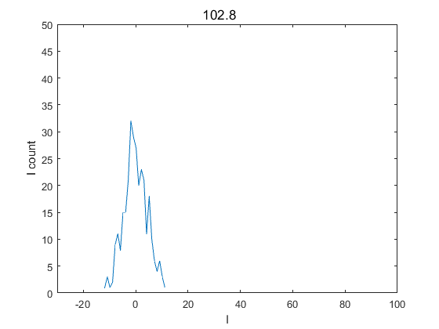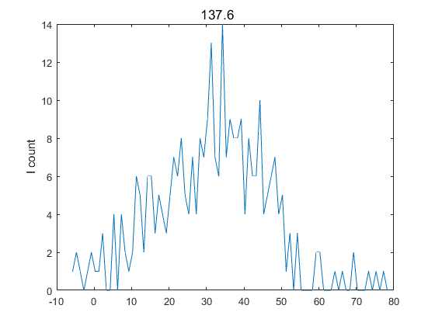

Figure 2. The mean value of current is related to the variance

The mean value of H during network operation can be obtained by convolving the firing number of neurons.

$$\begin{aligned}H_{all}^{EE}=\int_{-∞}^{+∞}{nfe\left(x\right)e^{-\left(x-t\right)/τ^{EE}}dt}\#\left(2\right)\end{aligned}$$

Combined with the relationship between the mean and variance of the current variable, we can get all kinds of information during the network operation.

**2.Model establishment**

**2.1 Single neuron**

I ti

I mean ti

V noref mean ti

convolution

Ref ti+1

Nf ti+1

I mean ti+1

>=M

V distribution ti

I mean ti

I ti distribution

Plus

<M

V distribution ti+1

V mean ti+1

V mean ti

Figure 3. Single neuron IVMM process

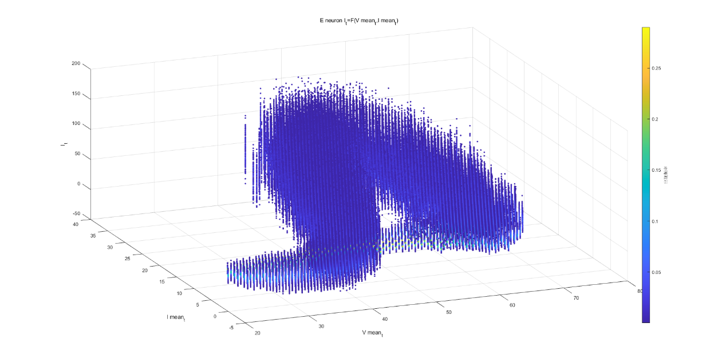

Figure 4. Single neuron current distribution matrix

However, this strategy has another problem compared with the full model. That's how to add up the current and the voltage.

I used the following methods, rearranging the current:

|  |  |  |  |  |  |
| --- | --- | --- | --- | --- | --- |
| V | | | | | |
| 1 | 2 | 4 | 7 | Nan(mean ref) | nan |

If not have Hei

|  |  |  |  |  |  |
| --- | --- | --- | --- | --- | --- |
| I | | | | | |
| 19 | 21 | 6 | 9 | nan | nan |

If have Hei

|  |  |  |  |  |  |
| --- | --- | --- | --- | --- | --- |
| I | | | | | |
| 21 | 19 | 9 | 6 | nan | nan |

If only have Ieex

I obeys Poisson distribution with lambda equal to 7

**2.2 mean field**

Convolution

multiply

V noref mean ti+1

Nf ti+1

I mean ti

V noref mean ti

Ref proportion ti

(or Proportion of not Ref)

V mean ti+1

Nf ti+1

Ref proportion ti+2

I ti+2

**equal to**

Nf ti+1

>=M

Plus

<M

V distribution ti+1

V mean ti+1

Figure 5. Mean field IVMM process

In the mean field model, the specific distribution of neurons at each time cannot be obtained. In the single neuron model, we can clearly know how many neurons are not in the refractory period at present. In the mean field model, we need to **add one-dimensional ref** (or how many neurons can fire). After all, it is obvious that when 100 neurons and 1000 neurons are under the same average voltage V and average current I, their dynamics are inconsistent.

Another difference in this model is that we **predict the distribution of the next state according to the current state** (that is, the result of plus in the single neuron model).

Because $V^{noref}$ mean and $V^{all}$ mean can be obtained from each other when ref information. $V^{noref}mean=\frac{N}{N-Nref}*V^{all} mean$, and $I^{noref} sum=\frac{N-Nref}{N}*I^{all} sum$. And:

$$\left\{\begin{aligned}V_{t+1}=F\left(V_{t},{I^{noref}}_{t}\right) \\ \left(M/n\right)*{nf}_{t+1}=I^{noref}-\left(V_{t+1}-V_{t}\right)\end{aligned} (3)\right.$$

So I have tried to run the model with voltage information only and calculate fr information:

Nf ti

convolution

V mean ti+1

I mean ti

V mean ti

Ref proportion ti

(or Proportion of not Ref)

Ref proportion ti+1

I ti+1

Nf ti+1

V mean ti+1

V mean ti

I mean ti+1

I mean ti+1

Figure 6. Mean field IVMM process 2

But the actual operation found that this was not possible. Later, I also wanted to understand why this happened. At the next moment, nf and V are bound. The result calculation of the full model (3) must be true, because **the conclusion of (3) is "result", and the change of V and fr is "cause"**. But the above operation reverses fr with V and (3) as the causes. There is a problem with this logic. The V and fr at the next moment must be considered at the same time.

**3. Model performance**

Basically close to full model, but there are also differences.

The difference between the discharge rate and the maximum autocorrelation is simply that the MM result will be more "regression" than the Full result. If the full value is greater, the MM will be smaller; If the full is small, the MM will be larger. One of the reasons for this is the way my MM generates sequences. Because the current parameter matrix is not necessarily able to fill all the spaces, one step in generating the sequence is to select the state transition matrix from the space around the state if the state is not included in the matrix. This will "regress" the state to the center of the state transition matrix. This phenomenon may also be related to the loss of information in the simplification process (time discretization, average voltage, current and refractory period neuron proportion numerical discretization).

**4. Improvement direction**

In the single neuron model, we can try to find the relationship between current distribution and voltage in the full model, and optimize the steps of voltage and current addition.

In the mean field model, we can try to obtain the transfer matrix by mathematical calculation instead of learning statistics, so that the numerical value does not need to be discretized.

**5.Code usage**

(1) Get a lot of full model results

>main_mutimodel

(2) Calculate the probability transfer matrix

>load('full_model_res.mat')

> [estate_matref,istate_matref] = compute_IVrefMM(res_full_model,params);

>load('full_model_res.mat2')

> [estate_matref,istate_matref] = compute_IVrefMM(res_full_model,params, estate_matref,istate_matref);

…

(3) Run IVMM (This step can be directly carried out when there is a transfer matrix “eirefstate_mat.mat”)

>IVrefMM_list = generate_IVrefMM(estate_matref,istate_matref);

>plot_fft(IVrefMM_list(1,:),IVrefMM_list(2,:));